Key dates and information:
Traditional tales have been changed through time as they have been told.
Our phonics this half term will focus on…
-Phase 3 sounds and tricky words
-Decoding sentences.
-Writing captions and sentences.
Our Literacy texts this half term will be…
The Gingerbread Man
Three Billy Goats Gruff
The Enormous Turnip
Goldilocks and the Three Bears
Little Red Riding Hood

Our White Rose Maths schemes his half term are...
- Building 9 and 10 (3 weeks)
- Consolidation (3 weeks)
Our vocab ten
(provocations to develop)
Traditional | Tale
Characters | Settings
Morale | Recipe
Sequence | Changed
Long ago | Different/ Same

Top 5 facts
Traditional tales can also be called fairy tales.
Fairy tales started as stories that people told one another.
Traditional tales can be a bit different depending on which book you read.
Some traditional tales have been around for thousands of years.
The start of the story saying ‘Once upon a time’ dates back over 700 years!
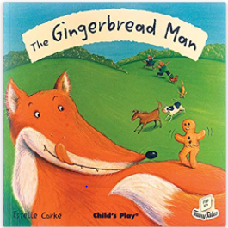
What happened once upon a time?

Spring 2

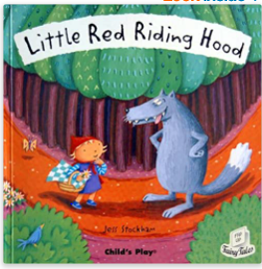
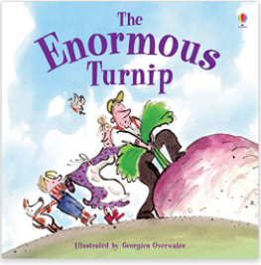
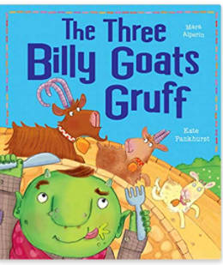

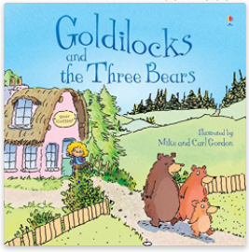
Specific Skills and Knowledge:
Children begin to understand that the past stems back much further than immediate family. Children comment on a historical figure from the past through a story. Children can order (with support) 3 pictures in chronological order.
Children begin to understand that religions have important stories within them and they teach believers key messages. Children learn the Easter story.
Significant events and people:
The Brothers Grimm collected lots of famous traditional tales into a book.
Hans Christian Anderson wrote many famous fairytales.
Artists to explore:
Range of illustrators from traditional/ fairy tale stories

