Our Literacy texts this half term will be…
Firework night- factual text
Rosie’s Walk- Pat Hutchins
Diwali- factual text
Farmer Duck- Martin Waddell
The Gruffalo – Julia Donaldson
Billy and the Beast – Nadia Shireen
The Nativity Story
Christmas- Stickman- Julia Donaldson

Our phonics this half term will focus on…
- Level 2 phonics completion with individual assessments.
- Level 3 for those who are ready.

Our White Rose Maths schemes his half term are...
- It’s me 1,2,3 (3 weeks)
- Light and Dark (3 weeks)

Our vocab ten
(provocations to develop)
Celebration / Celebrate | Diwali
Firework | Occupation
Nativity | Christian
Hindu | Preposition words (behind, around, through)
Religion | Fact

Top 5 facts
Guy Fawkes tried to blow up the houses of Parliament.
Diwali is the festival of lights.
Lights are used in many special celebrations around the world.
The nativity story is set in a stable.
Christmas is the celebration of the birth of Jesus.
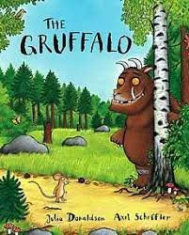
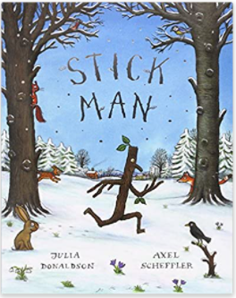
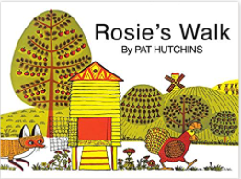
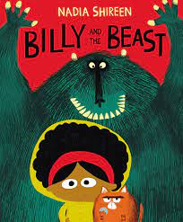
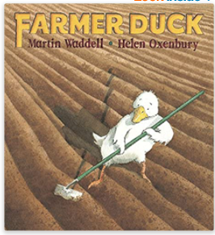
What’s Awesome about Autumn?
Autumn 2
Artists to explore:
Rangoli artists from around the world

Significant events and people:
- Guy Fawkes
- Jesus
- God
- Rama and Sita
- Lakhsmi
Key dates and information:
Firework night- 5th November
Diwali – 12th November
Christmas -25th December

