Our Literacy texts this half term will be…
Harry and the Dinosaurs go to School – Ian Whybrow
Leaf-Man- Lois Ehlert
Owl Babies- Martin Waddell
The Little Red Hen
The Leaf Thief- Alice Hemming

Our phonics this half term will focus on…
- Recap Level 1 phonics skills
- Start Phase 2

Our White Rose Maths schemes this half term are...
- Getting to know you (3 weeks)
- Just like me (3 weeks)

Our vocab ten
(provocations to develop)
Season | Senses
Harvest | Leaves
Nocturnal | Pumpkin
Habitat | Seed
Crunchy | Change

Top 5 facts
Leaves change colour because they receive less sunlight.
Trees lose their leaves to make sure they survive the winter.
Harvest time is when the farmers gather in their crops.
Owls are nocturnal.
Some animals gather food for the winter in Autumn time.
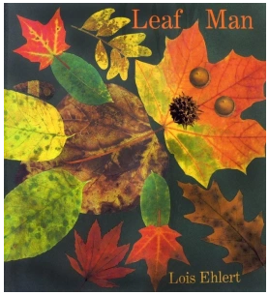
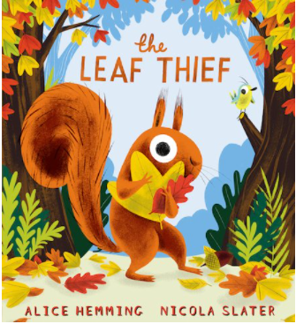
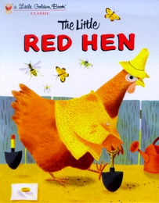
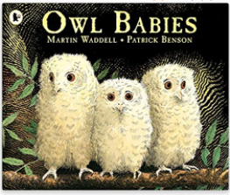
What’s Awesome about Autumn?
Autumn 1
Artists to explore:
Leaf Art
Andy Goldsworthy Lorenzo M.Duran

Significant events and people:
Harvest festival is a celebration of food that is grown on the land.
The role of farmers in our society.

Key dates and information:
Harvest festival is normally near the end of September (around the Harvest moon)
Autumn officially begins on September 23rd.

