Year Group: 5 Autumn Term
Throughout the term, please choose from these learning tasks below. Learning can be recorded in many ways so please be creative! You may choose to record your learning by taking photographs or videos and emailing them to your teacher. Please bring your home learning to school so that it can be displayed and shared with your friends.
Art:  Using the clip below from YouTube – Study the different ancient Egyptian drawings and have a go at mimicking the styles.  Can you use a range of media? Pens, paints, pencils, chalk, crayons. What affects can you create?  Ancient Egyptian Drawings and Paintings in tombs - YouTube | D&T:  Make a Shaduf - Shaduf is a hand-operated machine used to transport water from a lower level to a higher one. It was used by the ancient Egyptians to help water crops.  *Please find instructions on the back of this sheet. | Science:  Mummify your own fruit!  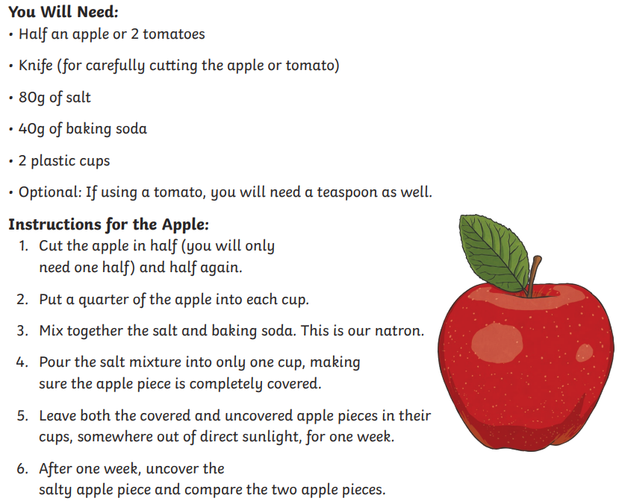
Geography:  Find out ‘Why is the river Nile so important?’ – Record your findings in a mind map!  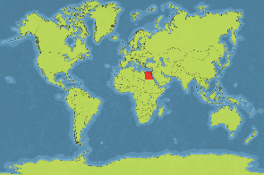 | History:  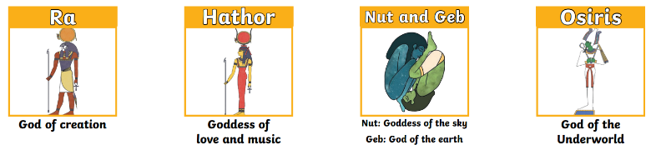  Write a fact file about a famous Egyptian God and state how they impacted the time period! | Maths:  Using Egyptian number symbols, create your own Maths number sentence problems.  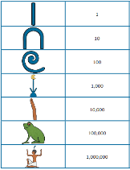
Music:  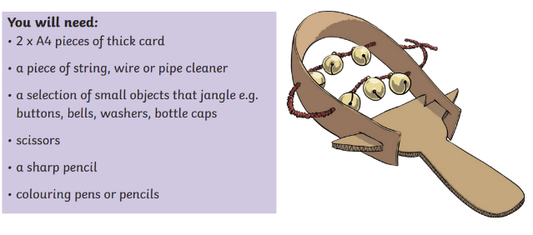  Make an Egyptian Sistrum. | Computing:  Create a PowerPoint presentation all about Ancient Egyptians – You can include your learning from school and any research you do at home!! | English:  Write like an Egyptian!  Have a go at writing your name in Hieroglyphics…  Can you then have a go at cracking the code?  