Optional Home Learning Grid
Year Group: Year 2 Topic: Rainforests Term: Spring
Throughout the term, please choose from these learning tasks below. Learning can be recorded in many ways so please be creative! You may choose to record your learning by taking photographs or videos and emailing them to your teacher. Please bring your home learning to school so that it can be displayed and shared with your friends.
Art:  Can you make your own animal mask?  Think about the types of animals that live in the rainforest and how they use camouflage to hide from predators. Bring them into school so we can add them to our display.  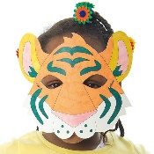  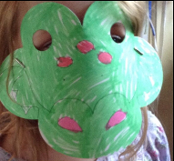  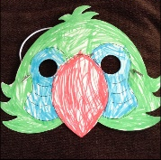 | DT:  Design your own rainforest animal with features that will allow it to live in all four layers of the rainforest.  Make sure it has the ability to move freely through the leaves at the top of the trees in the emergent layer, the branches of the canopy layer, the small trees in the understory and the thick, dark forest floor.  Colour is very important in the rainforest as some animals want to stand out and other animals want to stay hidden. Draw, colour and label the features of your creature and don’t forget to think of a suitable animal name! | 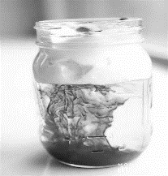  Science:  Have a go at making your own rain cloud!  You will need: A cup or jar, shaving foam, food colouring.  Directions:  1.Fill cup with cold water about ¾ full. You need to leave space for the shaving cream.  2.Squirt a thin layer of shaving cream over the water. Fill in any holes. Be sure not to add too much – shaving cream does rise a bit and you don’t want it to be too thick. If you put too much, you can scrape some off using a spoon.  3.Use the spoon to help even out the layer of shaving cream.  4.Drop several drops of food colouring onto the shaving cream. Check the water to see if you can see the food colouring seeping through the shaving cream. If you do not see this, add more food colouring until it goes through.  5.Once you see the food colouring go through the shaving cream, sit back and watch to see what happens!
Geography:  Follow these instructions to make your own rain gauge, all you need is an empty plastic bottle:  https://theimaginationtree.com/homemade-rain-gauge/  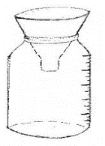  Put your rain gauge in the garden and check it regularly to record how much rain has fallen. Record your results and bring them to school after a few weeks.  Use Google maps and earth to discover the 7 continents and 5 oceans of the world. You could create your own map. | Computing:  Search for paintz.app and paint a picture of a rainforest or an animal that lives in the rainforest. Don’t forget to think about different brushes, thickness, shapes, colours and adding text. Print/email your pictures so we can display them in school!
English:
Use your research skills to create a fact file about the rainforest. It could be about your favourite animal. What is the habitat like? What does it eat? How does it live? Or find out about the plants that are found there.
Useful websites:
- Topmarks- rainforests
- BBC Bitesize- what is a rainforest habitat?
- National Geographic Kids- save the rainforest
- BBC Teach- Go Jetters (continents)

