Wadebridge Primary Academy
Coronation Crown Competition

To celebrate the coronation, Mrs Keat launched a competition to design a crown fit for a new king. The crown needed to reflect King Charles’s interests and passions and include designs which would symbolise both the countries of the United Kingdom and the Commonwealth.

As always, the standard of art work was high with crowns being made from a wide range of resources including natural materials to reflect King Charles’s passion for environmental issues and paper flags to represent all the nations that belong to the Commonwealth and UK.

The entries were so brilliant that Mrs Keat had a very difficult job to choose the winners. After much deliberation, the winners were announced during Friday’s celebration assembly and the prizes were awarded.

Here are the winners and highly commended runners-up in each category:

EYFS: Winner - Lennon
Runners up – Bertie and Harry

KS1: Winner - Dolcie
Runners up - Iris and Lily

KS2: Winner - Estelle
Runners up – Olive and Bella

Congratulations to the winners and well done to everyone who entered a crown. They were truly amazing! Well done!
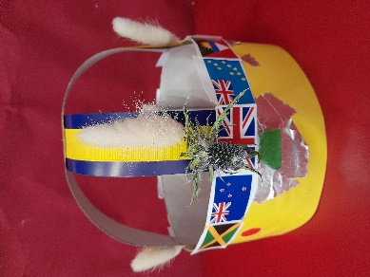
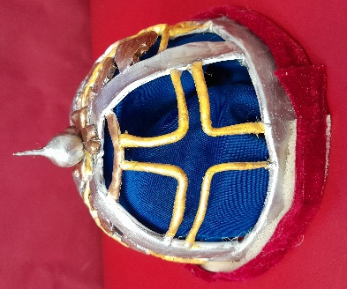
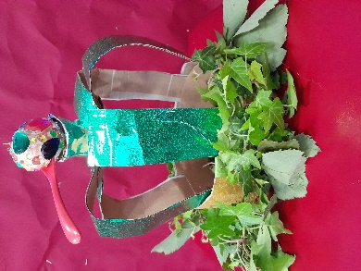

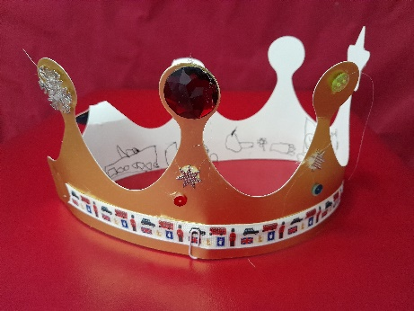
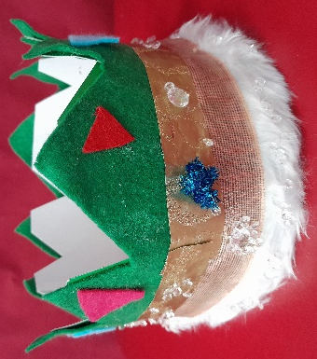
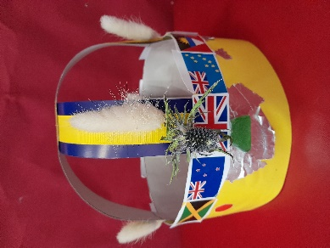
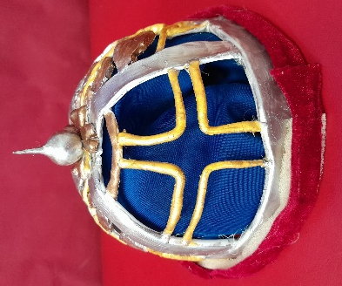
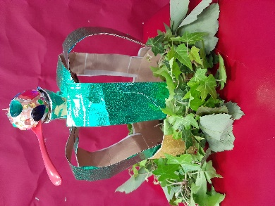

EYFS 1st Place: Lennon Runners-up: Bertie Harry

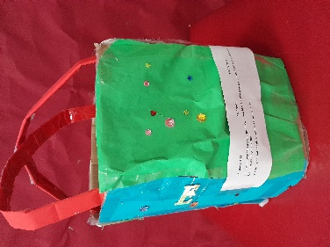
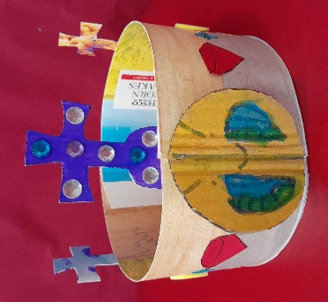

KS 1 1st Place: Dolcie Runners-up: Iris Lily
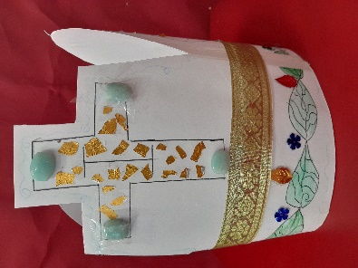
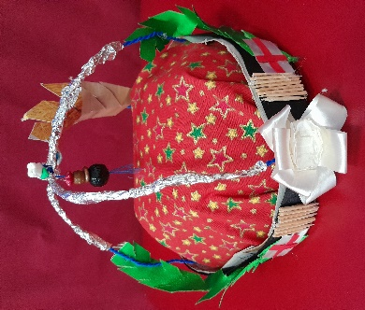

KS2 1st Place: Estelle Runners-up: Bella Olive

